Beverly Coleman Scholarship Award

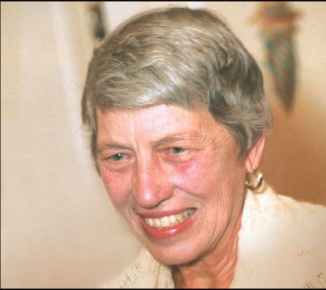
In 2010, Dr. Douglas Coleman and his son Thomas provided the Northeast Harbor Library’s Scholarship Program’s Endowment Fund with gifts to establish the Beverly Coleman Scholarship Award in memory of Doug’s late wife, who was Tom’s mother. Beverly volunteered at the Library for more than twenty years and was involved with many other community organizations such as the Wild Gardens of Acadia. Beverly Coleman Scholarship Awards will be supported by the interest generated by the principal.

Eligible candidates must be recipients of Northeast Harbor Library scholarships and must have a 3.0 or higher GPA . No student will be eligible for more than one Beverly Coleman Award. Awards will be granted by the Library Scholarship Committee on the basis of a paragraph by candidates submitted with their regular re-application for the continuation of their library scholarships. The successful candidate will exemplify Beverly Coleman’s lifetime commitment to community service, conservation, horticulture, and history. Awards will be announced and publicized in the winter season.

Again in summary:

- Eligible candidates must be recipients of Northeast Harbor Library scholarships.
- Eligible candidates must have a cumulative GPA of 3.0 or higher.
- No student will be eligible for more than one Beverly Coleman Scholarship Award.
- An award need not be given in a year in which no suitable recipient has been identified.
- Awardees will be chosen by the Scholarship Committee on the basis of the paragraph written by interested students when re-applying for continuation of their grants.
- The Scholarship Committee will consider applicants who share Bev’s interest in:
1. Community Service
2. Conservation
3. Horticulture
4. History
- Preference will be given to applicants who have demonstrated a commitment to one or more of the above noted interests.
- Awards will be announced and publicized in the winter season.

